Spelling Bee, The Competition

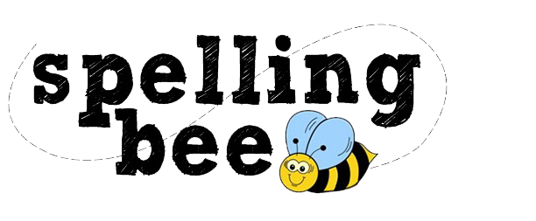

**Intended Platforms:** Windows PC, iOS, and Android

**Projected Ship Date:** Q4 2018

**Target Age:** Kids and Up

**Genre:** Typing, Learning, and Management

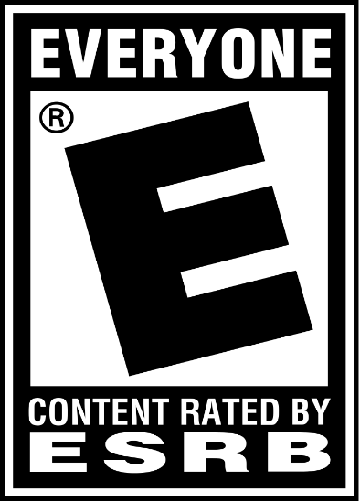

Table of Contents

Game Outline – Page 3

Characters – Page 4

Gameplay – Page 4

UI and Interface – Page 7

Game World – Page 8

Game Modes – Page 9

Monetization – Page 10

Game Outline

**Story**

Lukas is a new Spelling Bee competitor looking to make it big in the scene. Being the ambitious 16-year old he is, if Lukas doesn’t get the number one spot on the Global Leaderboard, he will retire for good. Make it big or go home, that’s his motto!

**Main Focus**

You are a new Spelling Bee competitor in your high school years, looking to make it big! Balance the actions of Sleeping and Studying in order place high in local and international competitions, as well as make it to the top in the Global Spelling Bee Leaderboards. You have a time limit set, use your skills in order to place high and achieve your goal!

**Progression**

As the player places high in competitions, their Global Ranking increases. At certain points, higher difficulty competitions will open up and more words needing to be memorized will unlock. These words are obviously harder to learn and have an increased character count.

Characters



**Lukas**

The overly ambitious 16-year old looking to steal the Spelling Bee crown and all the prize money for himself.

**Lukas’ Mom**

She doesn’t want Lukas to continue his dream, but she’s supportive otherwise..

Gameplay

**Day Cycle**

Spelling Bee plays like a management game. Each day you’re allotted a certain amount of time and you’ll have to choose how much time you spend on each action available. Competitions open for registration every three days so use your time wisely!

**Actions**

Sleeping:

Consumes the rest of the day, gain ENERGY based on how much time you sleep!

Studying:

Consume 1/4 of the day, take out your constantly updated Spelling Bee “Bible” and study based on how much energy you have saved up. (Max time is 4 minutes)

Practice Competition:

Consume 1/2 of the day, run through a practice competition that results in no rewards or consequences.

Competition:

Consume 1/2 of the day, compete in a Local or International Spelling Bee competition.

Energy:

This resource dictates how much time you’ll have each study session. It is an option not to sleep for a day, however, this will result in not having as much energy to study the next day. You can only gain energy by SLEEPING!!!

**Competition Gameplay**

Plays much like a regular Spelling Bee competition in which you will compete against other students in a round-based format.

Phase 1:

Word is given to the player through an audio cue

Phase 2:

You’ll have a sparingly one minute to type out the correct spelling for the word in the pop-up text box on screen.

There are assists that can help you in a tight situation. You can ask for a definition or a sentence the word is used in. Be wary though, as these do not stop the time from ticking down.

Phase 3:

Competition judges evaluate whether or not you got the word correct. The player moves on to the next round if they pass and drop out of the competition if they fail.

The AI competitors also go through this check.

Phase 4:

Start the next round with the competitors that passed, start from Phase 1 again until there is one person left standing.

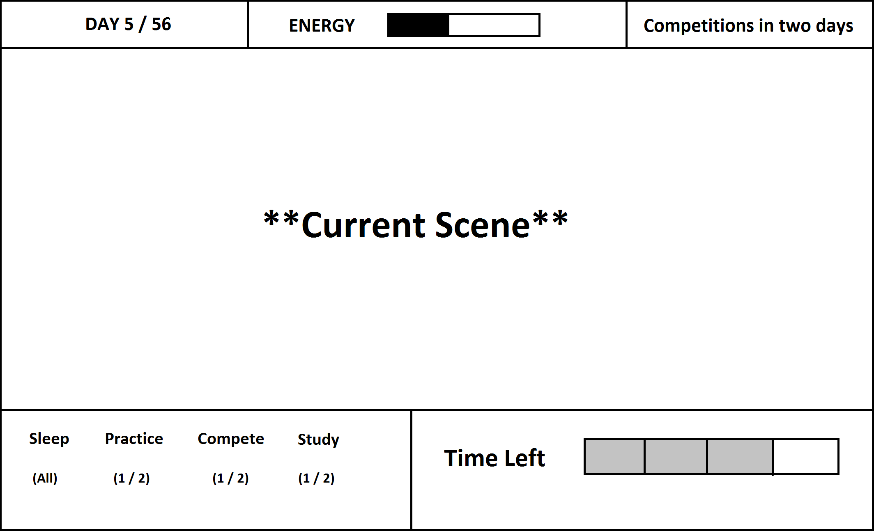UI and Interface

Game World

**Setting**

Atlanta, Georgia U.S.A.

**World Map**

Depending on what action the player chooses, a little animation will play before it happens. Otherwise there’ll be a static or animation scene of the current action running.

**Locations**

* Player’s Home
* Competition-Hosted Rooms

**NPCs**

* Mother
* Coach
* Spelling Bee Competitors

**Music**

* Overworld music has a soft, cheery melody
* Competition music is tense like in the Ace Attorney trials
* Studying plays a calming, melodramatic song

Game Modes

**Singleplayer**

Story Mode:

The main game mode where the player goes on a journey to be the #1 Spelling Bee competitor.

**Local Multiplayer**

Flash Bee:

A variant of the competition mode except players are given 30 seconds to spell the word instead of the usual minute.

“Spell the Word”:

An 8 round game mode where players are all given the same word. Each correct answer rewards a point and whoever has the most points at the end wins the game.

In the local version of this mode, all players enter using the phone app. Words are given on the screen and everyone types it in on their phones.

**Online Multiplayer**

Competition Mode:

Players take part in a Spelling Bee competition that uses an ELO ranking system.

Flash Bee:

A variant of the competition mode except players are given 30 seconds to spell the word instead of the usual minute.

“Spell the Word”:

An 8 round game mode where players are all given the same word. Each correct answer rewards a point and whoever has the most points at the end wins the game.

Monetization

**Base Game Price:** $60

**DLC**

Expansions:

* Will include updated word libraries
* New opponents and competitions!
* Priced at $5 each
* Three planned post-launch